**Module 1 Questions:**

**Q1**: **Explain in about 350 words why M&E informs good programming practice. (10 marks)**

M&E plays a critical role in good programming practice. First of all, it helps to determine if a programme or project is on track in comparison to the set goals and targets and also when changes need to be made. Through M&E, you can identify and assess the quality of activities being conducted, easily understand whether strategic changes need to be made, form the basis for those changes and act accordingly. It allows you to correct any identified errors as soon as possible. M&E also assists in identifying the most valuable and efficient use of resources. It allows programme implementers to allocate and re-allocate resources if and when needed.

It is essential in identifying and concluding the extent to which a programme can be considered a ‘success’. It details whether programme efforts have had a measurable impact on expected outcomes and have been implemented effectively. Through M&E and feedback on whether the projects and programmes are achieving aims in line with the community needs, M&E is a powerful accountability mechanism. This is incredibly important in the donor world, as accountability and reliability of your NGO and projects will determine collaborations and continued partnership with donors.

M&E also enables us to learn from past success’ and challenges and ensures that current and future projects and programmes are better informed which will therefore increase the likelihood of continued future success.

Project managers and teams leading projects will find satisfaction in the success of their work. Through M&E, they will identify strengths and weaknesses, and make better informed decisions based on feedback from M&E processes which will lead to improved programming practice.

According to the UNDP[1], *“Without effective planning, monitoring and evaluation, it would be impossible to judge if work is going in the right direction, whether progress and success can be claimed, and how future efforts might be improved.”*

In summary, monitoring and evaluation together provide the necessary data to guide planning, to show a project’s progress against defined goals, to assess what is working and what is not, to determine changes that need to be made, increase accountability, allocate resources in better ways and improve staff performance which all in turn, inform good programming practice.

**Q2**: **Describe the fundamental similarities and differences between Monitoring and Evaluation. (10 marks)**

Monitoring is the tracking of key elements of programme performance on a regular basis. In contrast, evaluation is the episodic assessment of the change in targeted results that can be attributed to the programme or project interventions, or the analysis of inputs and activities to determine their contribution to results.

According to the UNDP, monitoring “*can be defined as the ongoing process by which stakeholders obtain regular feedback on the progress being made towards achieving their goals and objectives”* and that evaluation “*is a rigorous and independent assessment of either completed or ongoing activities to determine the extent to which they are achieving stated objectives and contributing to decision making”.*

The differences between M&E can best be identified by time, scope, participants, process and written outputs.

Time: Monitoring is an ongoing progress that generates information about the programme while it is being implemented. It is a routine collection and analysis of information to track progress against set goals. Evaluation takes place periodically, usually only at the end of a project, or midway through a project or if there is a change of phase.

Scope: Monitoring involves the day to day activities, inputs, outcomes and changes while evaluation involves the assessment of the overall project inclusive of the delivery of outputs, achievements of the goals and longer-term impact.

Main participants: Monitoring involves the project managers and staff, while evaluation will also often include both internal and external evaluators such as project staff, donors, consultants.

Process: As monitoring is regular, it will involve consistent meetings, interviews and monthly and quarterly analysis, while evaluation is episodic so will involve extraordinary meetings, extensive analysis and data collection.

Written outputs: Similar to above, monitoring will include regular reports and updates while evaluation will have a more extensive report and usually involve presentations and workshops.

“*Without careful monitoring, the necessary data is not collected; hence evaluation cannot be done well. Monitoring is necessary, but not sufficient for evaluation. Monitoring facilitates evaluation, but evaluation uses additional new data collection and different frameworks for analysis*.”[2]

In conclusion, monitoring an evaluation are often dependent on one another and it’s important to understand the differences and the inter-linkages between them.

**Q3:** **Describe the difference between formative and summative evaluation process and explain the time of each process in the life of a project. (10mrks)**

In development projects there are two main categories of evaluation, formative and summative. Formative evaluations focus on programme improvement while summative evaluations focus on prorgamme products, results and impact. Formative evaluations will provide direction on how best to achieve your goals, while summative evaluations will show you to what extent the programme is or has achieved its goals. Formative evaluations can assist in continuous improvement while summative evaluations measure outcomes against pre-determined goals and frameworks. Formative evaluations focus on the *process* while summative evaluations focus on the *outcome.* The main purpose of formative evaluation is to provide feedback to programme directors and staff about the functioning of that programme and some of the short-term outcomes. It helps programme staff improve and refine the programme early and keep it on track. Summative evaluations are useful to plan follow-up activities and future related programmes.

Formative evaluations are typically conducted during programme development and implementation, so in the early life cycle of a programme. Summative evaluations should be completed once your programme is well established or completed, so later in the life cycle of a programme.

Another difference between formative and summative evaluation is the person who conducts it. With formative evaluation, it is usually programme staff and sometimes an external evaluator, and with summative evaluation it is usually always an external evaluator.

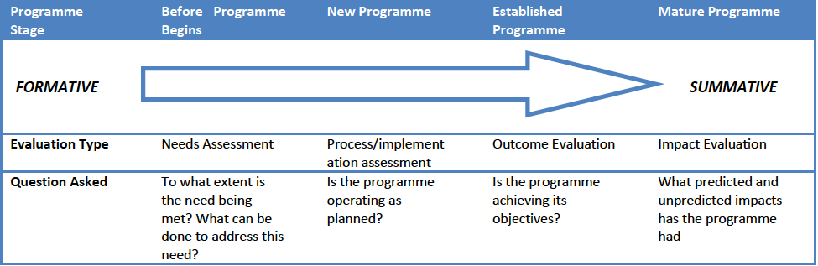

The image above, which was adapted from a CDC article[3], demonstrates the timeline, evaluation type and samples of the questions that need to be asked and answered for both formative and summative evaluations.

**Q4: With brief explanations, outline the key questions both formative and summative evaluations seek to answer. (10mrks)**

Since formative and summative evaluations are completed at different cycles in a programme/project life, the questions that they seek to answer will differ. Formative evaluations will focus on the ongoing programme and if any changes need to be made during that time while summative evaluations will seek to answer the overall-end project outcomes. Some examples of questions are outlined below:

Project Intentions: Formative evaluations will ask *‘Are key aspects of the programme functioning as intended? Are early outcomes moving in the right direction?’* while summative evaluation will ask *‘Did the programme have the intended effect on its target population? Are the outcomes attributable to the programme?’*

Beneficiaries: Formative evaluations will ask *‘To what extent are beneficiaries involved in decision-making and implementation of the project’ Do they have access or what are the obstacles? Are they satisfied with the project and activities?’* while summative will ask *‘What impact did the project have on beneficiaries and was it equally accessible and effective for all beneficiaries?’*

Additional project outcomes: Formative will ask *‘What are the strengths and weaknesses of the project? What barriers were identified and how to overcome them?’* while summative will ask *‘Is the project replicable and sustainable? What unintended impacts did the project have?’*

To summarize, the questions are focused on the stage the project is at, so questions for formative evaluations will focus on how the project and activities could be improved and changed slightly during implementation, while summative questions will focus on the overall end goals and outcomes.

**Q5: Explain the main limitations of the pretest-post-test model of evaluation. (10mrks)**

The pretest-post-test model of evaluation is a great tool to measure the impact of a project or programme, as long as its limitations are fully understood.

The main limitation of the pretest-post-test model is that there are many biases that could happen between the pretest and the post-test which will affect the data and KPIs. These are primarily external factors, and it’s difficult to establish if these external factors were significant in the changes associated with the project when completing the post-test.

This model cannot provide good evidence that the project’s interventions are directly attributed to the measured outcomes (net impact).

Another limitation is that because there is no baseline measurement done on groups or individuals that aren’t affected by the project, there is no way of judging whether the process of pre-testing actually influenced the results.

In summary, it is difficult to conclusively determine if the differences between the pretest and post test are directly related to the project or other factors. Therefore, as long as these limitations are understood then the pretest-post-test model can be an ideal tool used for evaluations.

1. UNDP, Handbook on Planning, Monitoring and Evaluation for Development Results, 2009 web.undp.org/evaluation/handbook/documents/English/pme-handbook.pdf
2. Adapted from UNEG Training – ‘What a UN Evaluator Needs To Know?’ Module 1, 2008
3. Adapted from CDC’s Healthy Community Programme, Building Our Understanding: Key Concepts of Evaluation. What is it and how do you do it? [www.cdc.gov/nccdphp/dch/programs/healthycommunitiesprogram/tools/pdf/eval_planning.pdf](http://www.cdc.gov/nccdphp/dch/programs/healthycommunitiesprogram/tools/pdf/eval_planning.pdf)